**PHASE 5**

**LESSON 5**

**PRACTICE ASSISTED 4**

**DEPLOYING YOUR APPLICATION**

**CREATING INSTANCE:**

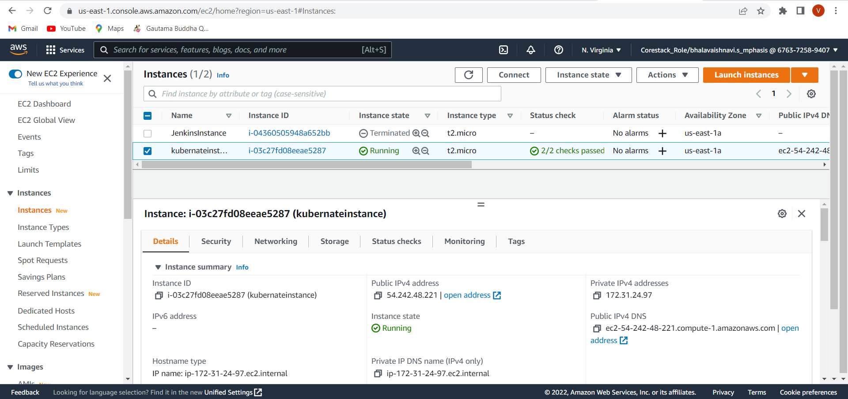

**SETUP ENVIRONMENT:**

